Registration No. 2025/CS/079
Index No. 25000799

( 01 )
Function call | n | Return value
0 | 8 | 384
1 | 6 | 48
2 | 4 | 8
3 | 2 | 2
4 | 0 | 1

( 02 )
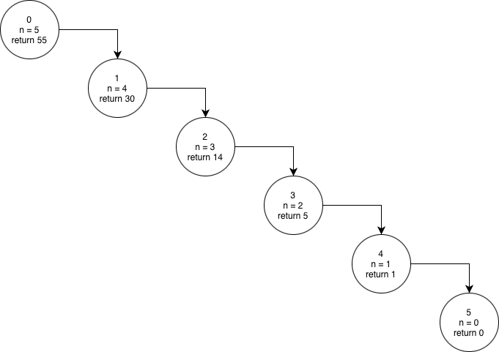
( 03 )
I./II.
Function | P | n | Return
0 | 1000 | 5 | 32000
1 | 2000 | 4 | 32000
2 | 4000 | 3 | 32000
3 | 8000 | 2 | 32000
4 | 16000 | 1 | 32000
5 | 32000 | 0 | 32000

III. 1000
IV. n being equal to zero (n == 0)
V. function calls itself while multiplying the value of P by 2 and decrementing the value of n by 1, until the value of n becomes zero and return the value of P.
VI. function calls itself while dividing the value of P by 2 and decrementing the value of n by 1, until the value of n becomes zero and return the value of P.
VII. value of P
VIII. 32000
IX.
def bacteria_growth(P, n, p):
if n == 0:
return P
else if P <= p:
return bacteria_growth (p, n – 1, p)
else if P >= 2000000:
return bacteria_growth (P/2, n – 1, p)
else:
return bacteria_growth (P*2, n – 1, p)
Function | P | n | p | Return
0 | 1000 | 10 | 100 | 1024000
1 | 2000 | 9 | 100 | 1024000
2 | 4000 | 8 | 100 | 1024000
3 | 8000 | 7 | 100 | 1024000
4 | 16000 | 6 | 100 | 1024000
5 | 32000 | 5 | 100 | 1024000
6 | 64000 | 4 | 100 | 1024000
7 | 128000 | 3 | 100 | 1024000
8 | 256000 | 2 | 100 | 1024000
9 | 512000 | 1 | 100 | 1024000
10 | 1024000 | 0 | 100 | 1024000

( 04 )
I./II./III.
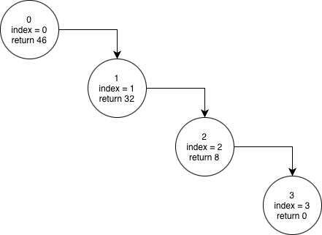
IV. [7, 12, 4]
V. value of index being equal to length of the array drone_distance
VI. function keeps calling itself while multiplying the current distance by 2 and adding the previously calculated distance, until the index value becomes equal to the length of the array.
VII. 0
VIII. 3 calls
IX. 46 units

